Landscaping with Eastern Red Cedars
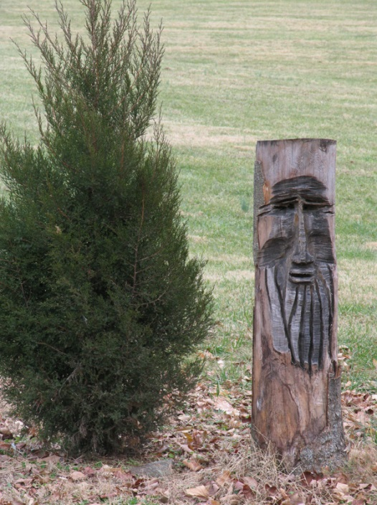
Evergreen trees and shrubs abound in the urban landscape. Boxwoods, spreading junipers, Chinese and Japanese hollies, taxus, arborvitae, pines and others provide screening and winter interest. Few of these are native to eastern North America and even fewer are native to the Bluegrass. Outside our cities and suburbs, the vegetation is largely deciduous: woody plants shed their leaves in the fall and green up again in the spring. By contrast, evergreens retain their leaves through the winter and shed them after the new ones have emerged.
For native plant gardeners, who strive to create an ecosystem based on their natural environment, the paucity of evergreens presents a challenge. Plants can go a long way toward blocking undesirable objects from view: an ugly commercial building, a parking lot, a neighboring yard’s trampoline or swimming pool, or a monotonous chain-link fenced lawn. Deciduous plants do a good job of this in summer, and they do retain some of their screening ability in winter when their branches are bare. But evergreens provide dense screening year-round and they also mitigate the drabness of a winter garden.
The eastern red cedar offers a solution to the urban need for visual barriers. Its scientific name, Juniperus virginiana, indicates that it is not a cedar at all, but a juniper. Its attractive blue green summer foliage, its regular conical shape, its fairly fast growth, and its resistance to deer suggest it for use on all but the smallest urban and suburban properties. Though perhaps most at home in moist limestone glades, it readily tolerates drought and adapts to a very wide range of conditions from thin gravelly soils to rich clays. It naturally occurs in the American east from Zone 2 to Zone 9.
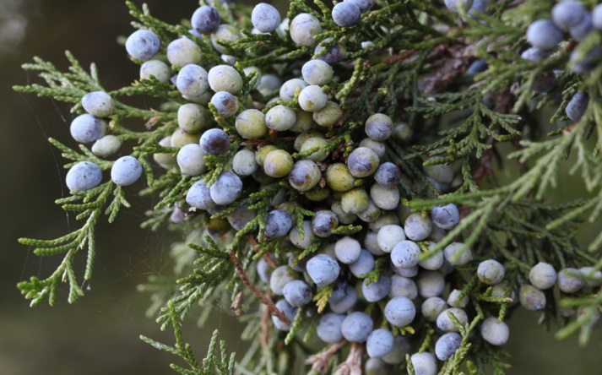
Like all junipers, eastern red cedars are dioecious, which means the male and female flowers appear on separate plants, and only those with female flowers produce the intensely blue berry-like cones beloved by birds. Male trees, of course, must grow nearby to allow for pollination and fruiting. For this reason, as well as for aesthetic effect, cedars should be planted in multiples. They can form a row for dense screening, especially if trees are offset against each other, namely planted in two parallel rows with each individual tree blocking the view through the gaps in the adjacent row. A casual grove of five or more trees looks natural, as if they spontaneously seeded themselves out in that spot; if the space permits, an additional tree or two could appear at some distance from that group. One can also create clusters that include cedars of different sizes by planting individual trees in different years, a design that would further mimic their appearance in nature.
Juniperus virginiana need full sun to grow into their characteristic dense and conical shape. They are not much troubled by destructive insects or diseases, though they should not grow near apples, crab apples or quinces, since they are an alternate host for cedar apple rust and cedar quince rust which produces a fungal growth of orange spores on their branches and foliage. Bagworms sometimes attack them, though that is an easily visible pest, best controlled by pulling the bags off the branches in winter or early spring and destroying them.
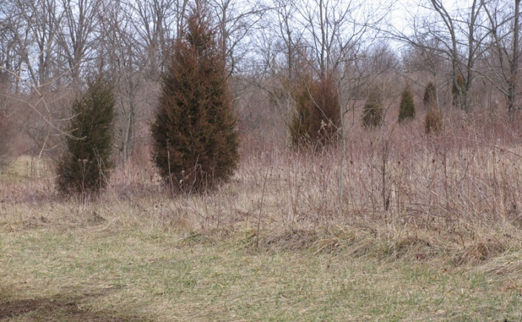
Perhaps eastern red cedars are rare in urban landscapes because they are so common in our rural environment. As early succession trees they populate disturbed ground where forests have been cut away or where once cultivated fields are returning to the wild. After completion of the Interstate highways from Lexington to Louisville and Cincinnati cedars settled in along those routes by the hundreds of thousands preparing the ground for a Kentucky forest to get going again on terrain that had been hugely disturbed by highway construction.
So, their ubiquitous presence in our rural areas may suggest that they can’t possibly be beautiful. But if the phrase “beauty is in the eye of the beholder” has any meaning, surely it applies here. A judiciously spaced assembly of cedars can enliven an empty expanse of suburban turf grass with regular shapes strongly visible through all seasons. If the turf grass grows into a natural meadow, so much the better, but this requires keeping other emergent woodies under control. For remember the early successional nature of cedars: they emerge in places where a forest wants to follow.
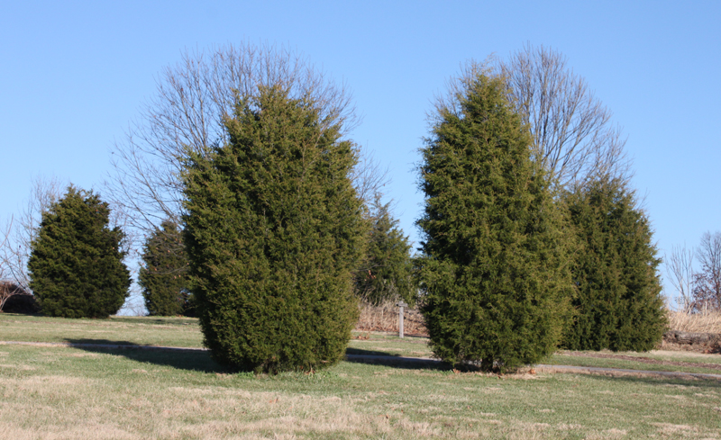
Beate Popkin

